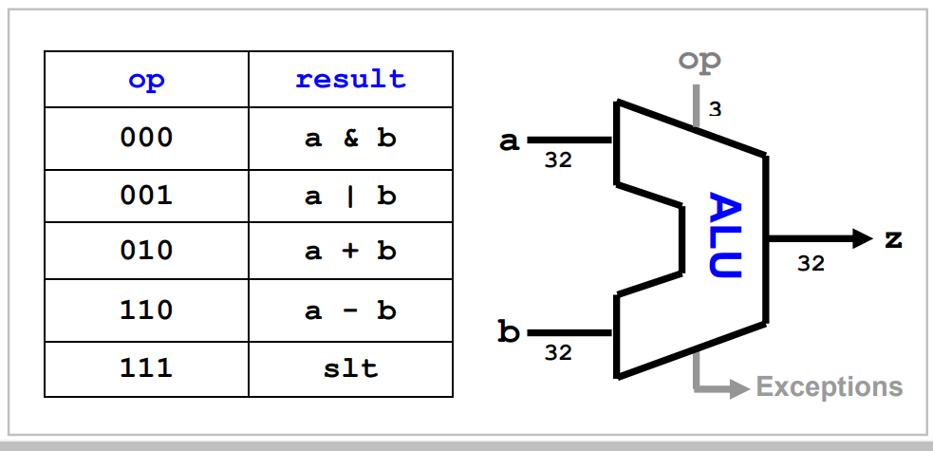We would like to build is the arithmetic-logic unit, the ALU, whose diagram is shown below. This is a versatile unit that performs a variety of operations based on a control input op (see the table in the diagram). In addition to z, the ALU also generates a number of exception signals (or flags) to indicate exceptions, such as a zero result, a carry, or a signed overflow. These exceptions are meaningful only for certain operations and then only for signed or unsigned input interpretation.